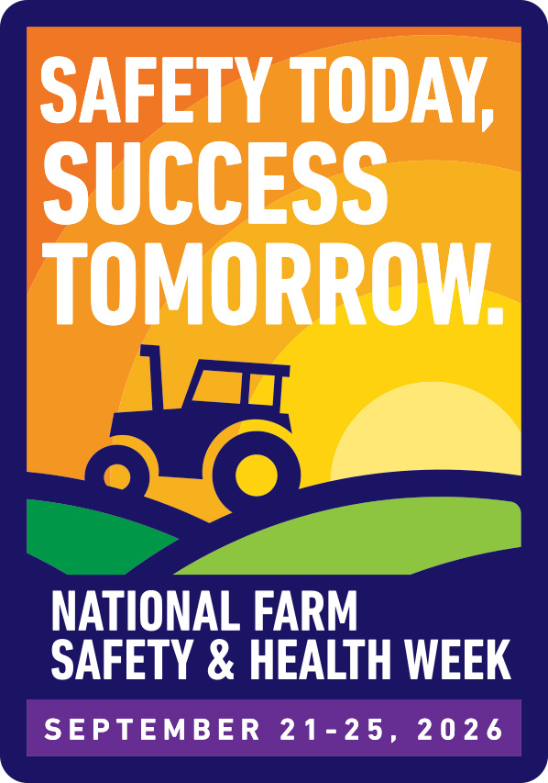
National Farm Safety and Health Week 2026

Social Media Toolkit
Note: Some promotions carry over onto the next page – make sure that you are copying the entire text for each promotion!
GENERAL NFSHW PROMOTION (two examples to use)
Example 1:
Agriculture is one of the most hazardous industries in the United States, but education and prevention can save lives. According to the National Institute for Occupational Safety and Health (NIOSH), roughly 100 agricultural workers experience a lost-work-time injury every day in the United States.

Join AgriSafe for the 2026 National Farm Safety and Health Week webinar series, a week dedicated to protecting the health, safety, and well-being of those who feed the world.

💻 11 FREE Webinars
📅 September 21–25, 2026

Explore important topics in agricultural health, safety, mental wellness, rural resilience, and injury prevention.

👉 View the webinar lineup here: https://www.agrisafe.org/nfshw/

#NFSHW2026 #FarmSafety #RuralHealth

Example 2:
Join AgriSafe for 11 free webinars on important agricultural health and safety topics during National Farm Safety and Health Week 2026!

📅 September 21–25, 2026

🔗 Register for all webinars: https://www.agrisafe.org/nfshw/

#NFSHW2026 #FarmSafety #RuralHealth

MONDAY, SEPTEMBER 21: Equipment and Rural Roadway Safety
9/21 Post 1:
FREE WEBINAR: Pathways to Progress – Safer Routes, Stronger Communities
📅 Monday, September 21 from 11:00 AM - 12:00 PM CT
Fall brings harvest season and increased traffic on rural roads. Tractors, combines, school buses, cyclists, and other motorists all share the road, making rural roadway safety more important than ever.
Join AgriSafe for this FREE National Farm Safety and Health Week webinar with presenter Jana L. Davidson to learn about common rural roadway hazards, practical safety strategies, and the Rural Road Ready initiative, which helps educate youth and communities on staying safe around farm equipment and rural roadways.
🔗 Register here:
https://learning.agrisafe.org/ecommerce/products/pathways-to-progress-safer-routes-stronger-communities
#NFSHW2026 #RuralRoadSafety #FarmSafety #TractorSafety

9/21 Post 2:
FREE WEBINAR: These Shared Roads – Using Stories in Rural Roadway Safety Education
📅 Monday, September 21 from 1:00 - 2:00 PM CT
Every trip on a rural roadway tells a story and some stories become powerful reminders of why safety matters. Join AgriSafe for this FREE National Farm Safety and Health Week webinar with presenter Amanda Wickman to explore how personal stories can strengthen rural roadway safety education. The session features a testimonial from a family impacted by a tractor-motor vehicle collision and highlights strategies for using storytelling to encourage safer behaviors on rural roads.
Learn how real experiences can help communities start conversations, increase awareness, and prevent future tragedies.
🔗 Register today:
https://learning.agrisafe.org/ecommerce/products/these-shared-roads-using-stories-in-rural-roadway-safety-education
#NFSHW2026 #RuralRoadSafety #FarmSafety #TrafficSafety #Storytelling
TUESDAY, SEPTEMBER 22: Health and Wellness
9/22 Post 1:
FREE WEBINAR: CALM Conversations on Access to Lethal Means
📅 Tuesday, September 22 from 11:00 AM - 12:30 PM CT
One conversation can make a difference.
Join AgriSafe for this FREE National Farm Safety and Health Week webinar focused on the CALM (Conversations on Access to Lethal Means) approach. Participants will learn how to have compassionate, effective conversations about reducing access to lethal means as part of a comprehensive approach to suicide prevention.
Presenter Dr. Noah Hopkins will provide practical tools for healthcare professionals, agricultural educators, community leaders, and others who support farmers, ranchers, agricultural workers, and rural families. Participants will gain confidence in discussing safety planning and connecting individuals with appropriate support and resources.
🔗 Register today:
https://learning.agrisafe.org/ecommerce/products/calm-conversations-on-access-to-lethal-means
#NFSHW2026 #MentalHealth #SuicidePrevention #RuralHealth #FarmWellness #FarmSafety

9/22 Post 2:
FREE WEBINAR: Noise in Agriculture – An Overlooked Occupational Hazard
📅 Tuesday, September 22 from 1:00 - 2:00 PM CT
The sounds of agriculture are familiar, but the impact of excessive noise exposure can last a lifetime.
Join AgriSafe for this FREE National Farm Safety and Health Week webinar on Tuesday, September 22, to learn about the risks associated with agricultural noise exposure and the importance of hearing conservation.
Participants will explore common sources of hazardous noise on farms and ranches, the effects of occupational noise exposure, and practical strategies to help protect hearing health.
This session is designed for farmers, agricultural workers, employers, healthcare professionals, and safety educators looking to better understand hearing risks in agriculture and promote prevention-focused practices.
🔗 Register today:
https://learning.agrisafe.org/ecommerce/products/noise-in-agriculture-an-overlooked-occupational-hazard
#NFSHW2026 #HearingHealth #FarmSafety #OccupationalHealth #RuralHealth

9/22 Post 3:
😴 FREE WEBINAR: The Cost of Fatigue in Agriculture – Practical Solutions to Protect Workers and Increase Productivity
📅 Tuesday, September 22 from 3:00 - 4:00 PM CT
Long hours, demanding schedules, and seasonal pressures can make fatigue a serious challenge in agriculture.
Join AgriSafe for this FREE National Farm Safety and Health Week webinar to explore how fatigue impacts agricultural workers, workplace safety, health, and productivity.
Participants will learn about common contributors to fatigue in agricultural settings and gain practical strategies to improve rest, recognize fatigue-related risks, and create safer, healthier work environments.
This session will provide farmers, ranchers, agricultural employers, and safety professionals with tools to better understand fatigue and implement solutions that support both workers' well-being and operational success.
🔗 Register today:
https://learning.agrisafe.org/ecommerce/products/the-cost-of-fatigue-in-agriculture-practical-solutions-to-protect-workers-and-increase-productivity
#NFSHW2026 #FatigueAwareness #FarmSafety #RuralHealth #WorkerWellness

WEDNESDAY, SEPTEMBER 23 - Generations of Farming
9/23 Post:
🌱 FREE WEBINAR: Telling the Story – Using Personal Experiences to Strengthen Farm Safety and Well-Being
📅 Wednesday, September 23 from 11:00 AM–12:00 PM CT
Stories have the power to connect, educate, and inspire change. Join AgriSafe for this FREE National Farm Safety and Health Week webinar to explore how personal experiences can be used to strengthen farm safety and promote well-being in agricultural communities.
Participants will learn how sharing real-life experiences can increase awareness, encourage safer practices, and create meaningful conversations around health and safety on the farm. This session will highlight storytelling as a tool for education, outreach, and prevention—helping farmers, families, and agricultural professionals connect through shared experiences and lessons learned.
🔗 Register today:
https://learning.agrisafe.org/ecommerce/products/telling-the-story-using-personal-experiences-to-strengthen-farm-safety-and-well-being
#NFSHW2026 #FarmSafety #RuralHealth #FarmWellness #Storytelling

THURSDAY, SEPTEMBER 24 - Confined Spaces and Rural Disaster Resilience
9/24 Post 1:
⚠️ FREE Webinar: Confined Space Safety in Agriculture
📅 Thursday, September 24 from 11:00 AM - 12:00 PM CT
Confined spaces are common on farms and ranches, but they can present serious safety hazards without proper awareness and preparation. Join AgriSafe for this FREE National Farm Safety and Health Week webinar on Thursday, September 24, to explore the dangers of confined spaces in agriculture, including grain bins, silos, manure pits, and other agricultural structures.
Participants will learn how to recognize confined space hazards, understand the risks associated with entry, and identify strategies to promote safer work practices in agricultural settings.
Whether you are a farmer, rancher, agricultural worker, educator, healthcare professional, or safety advocate, this session provides important information to help strengthen agricultural safety efforts and protect rural communities.
🔗 Register today:
https://learning.agrisafe.org/ecommerce/products/confined-space-safety-in-agriculture
#NFSHW2026 #ConfinedSpaceSafety #FarmSafety #GrainSafety #RuralHealth

9/24 Post 2:
🚨 FREE WEBINAR: Increasing Awareness for Confined Space Safety in Agriculture
📅 Thursday, September 24 from 1:00 - 2:00 PM CT
Awareness is the first step toward preventing confined space tragedies. Join AgriSafe for this FREE National Farm Safety and Health Week webinar on Thursday, September 24, to increase understanding of confined space hazards in agricultural settings.
Participants will review common confined spaces found on farms and ranches, including grain bins, silos, manure storage facilities, and tanks.
This session will help participants recognize high-risk situations, understand the dangers associated with confined space entry, and learn practical prevention strategies that can help protect agricultural workers, families, and communities.
🔗 Register today:
https://learning.agrisafe.org/ecommerce/products/increasing-awareness-for-confined-space-safety-in-agriculture
#NFSHW2026 #ConfinedSpaceSafety #FarmSafety #GrainSafety #RuralHealth

9/24 Post 3:
🌪️ FREE WEBINAR: More than FEMA: Building True Rural Disaster Resilience
📅 Thursday, September 24 from 3:00 - 4:00 PM CT
When disaster strikes, recovery takes more than emergency response—it takes resilient communities. Join AgriSafe for this FREE National Farm Safety and Health Week webinar on Thursday, September 24 at 3 PM CT to explore how rural communities can strengthen disaster preparedness, response, and long-term recovery.
This session will examine the unique challenges agricultural communities face during disasters and highlight strategies to build stronger support systems before, during, and after emergencies.
Participants will learn about the importance of collaboration, community partnerships, and proactive planning to improve rural resilience.
Discover approaches that go beyond immediate response to help farmers, ranchers, and rural communities recover and thrive after disasters.
🔗 Register today:
https://learning.agrisafe.org/ecommerce/products/more-than-fema-building-true-rural-disaster-resilience
#NFSHW2026 #DisasterPreparedness #RuralResilience #EmergencyPreparedness #RuralHealth

FRIDAY, SEPTEMBER 25 - Cancer Prevention
9/25 Post 1:
🌸 FREE WEBINAR: Boots, Bales, Biopsies – Women’s Health on the Farm
📅 Friday, September 25 from 11:00 AM - 12:00 PM CT
Women are a driving force in agriculture, but too often, their own health takes a back seat.
Join AgriSafe for this FREE National Farm Safety and Health Week webinar, happening Friday, September 25, and focused on women’s health in agricultural settings. Participants will explore unique health challenges women face while working in agriculture, including occupational health risks, cancer prevention, early detection, and strategies for prioritizing personal well-being.
This session will provide practical information to help women in agriculture make informed health decisions while continuing to support their farms, families, and communities.
🔗 Register today:
https://learning.agrisafe.org/ecommerce/products/boots-bales-biopsies-women-s-health-on-the-farm
#NFSHW2026 #WomensHealth #WomenInAg #CancerPrevention #FarmHealth

9/25 Post 2:
🩺 FREE WEBINAR: Cancer Knowledge, Exposure Beliefs, and Prevention Behaviors: Insights from Iowa’s Agricultural Communities
📅 Friday, September 25 from 1:00 - 2:00 PM CT
Understanding cancer risks is the first step toward prevention. Join AgriSafe for this FREE National Farm Safety and Health Week webinar to explore findings from research conducted in Iowa’s agricultural communities.
Participants will learn about agricultural workers’ knowledge of cancer risks, perceptions of occupational and environmental exposures, and prevention behaviors.
This session will highlight opportunities to strengthen cancer prevention education and improve health outcomes among agricultural populations through increased awareness and evidence-based outreach.
🔗 Register today:
https://learning.agrisafe.org/ecommerce/products/cancer-knowledge-exposure-beliefs-and-prevention-behaviors-insights-from-iowa-s-agricultural-communities
#NFSHW2026 #CancerPrevention #FarmSafety #OccupationalHealth #RuralHealth

