Flood Resources Tool Kit

Human & Animal-
Transmission of disease can occur between humans and animals

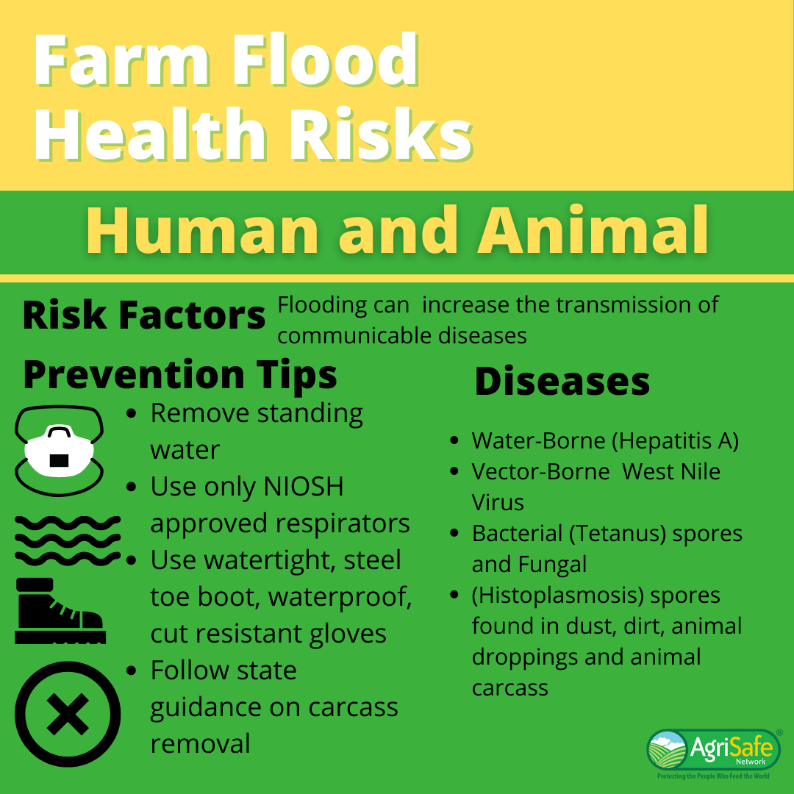

Heat Illness- Intense exposure to hot temperatures and high humidity can cause heat related illnesses.

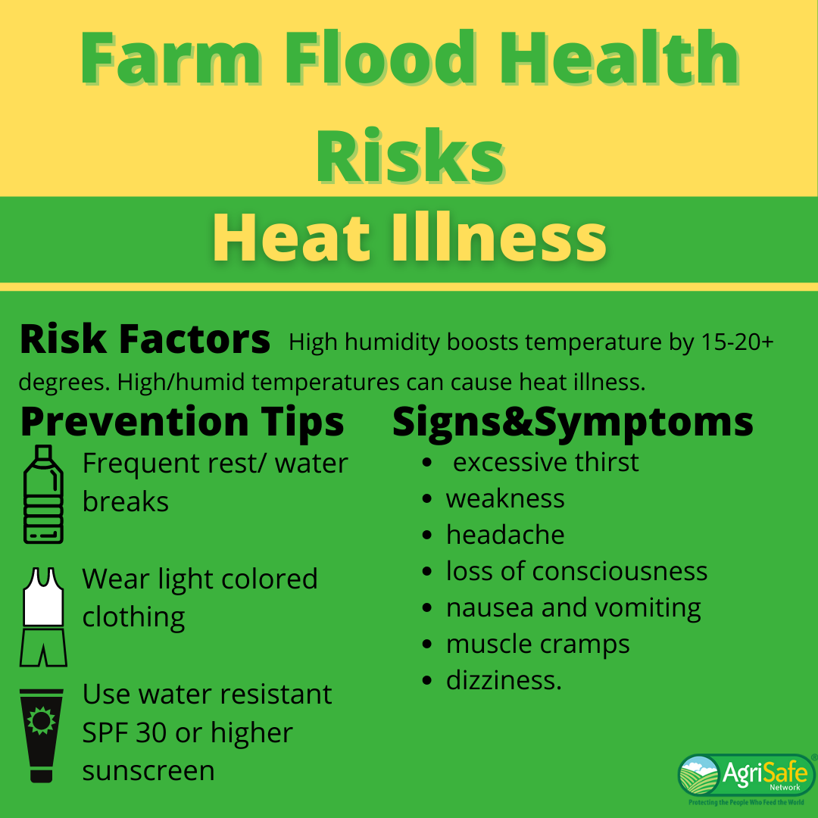

Stress- A flood can cause both emotional and physical stress.

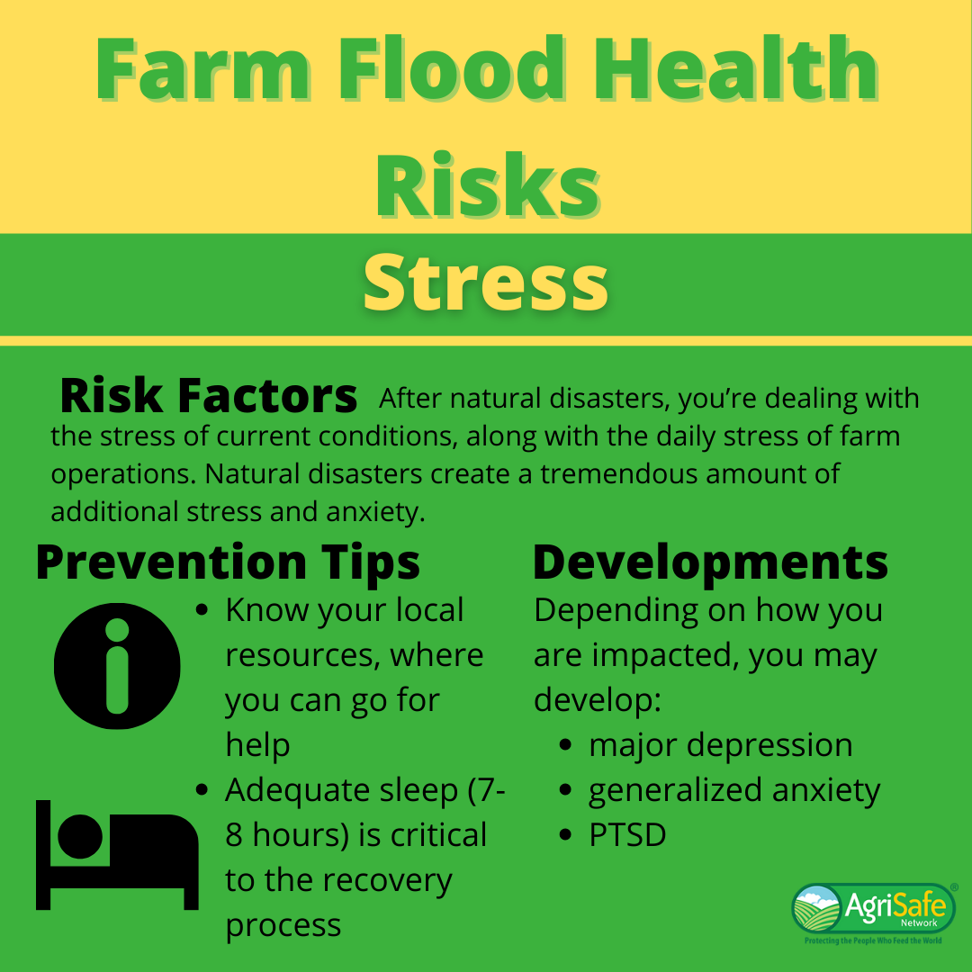

Chemicals- Flooded storage of pesticides and petrochemicals (e.g. oil, hydraulic fluid) can pose threats to human health.

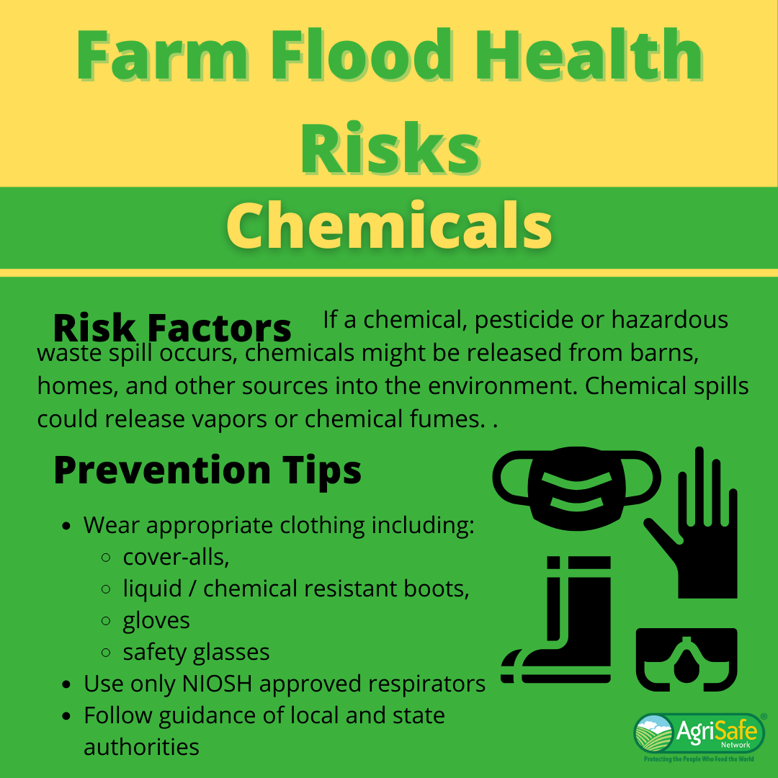

Mold- Microbial (e.g. mold) growth rapidly increases and spreads due to flooding waters.

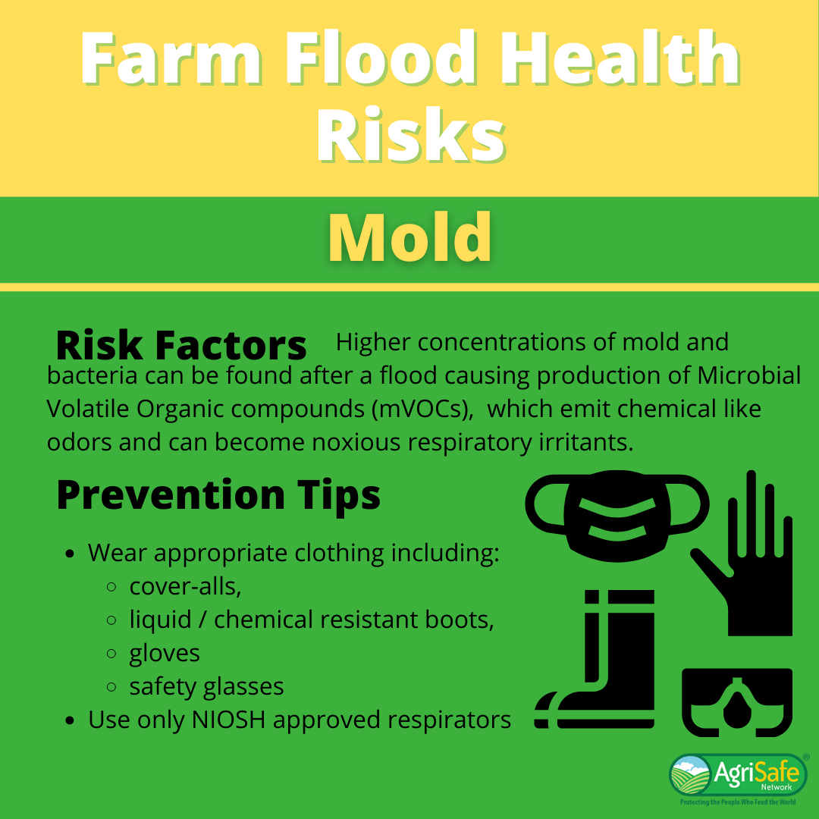

Well Water- Water may not be safe to drink, cook, bath or disinfect.

